The Derivatives of Sine and Cosine Discovery
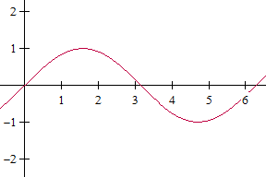
π/2
π
3π/2
f(x) = sin(x)
2π

1) Find the x values for which the tangent line is horizontal.

2) If the tangent line is horizontal at these x values, what are the y values on the graph of the derivative with these x coordinates? Write the points below.

3) At which x values does it appear that the slope of the tangent line equals 1? At which x value does it appear that the slope of the tangent line equals negative 1?

4) You now have 5 points that you can plot for the graph of the derivative of sin(x). Plot these points on the graph above. What function appears to be forming? How do you know?

5) The derivative of f(x) = sin(x) is _______________________.

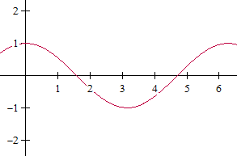
f(x) = cos(x)
π/2
π
3π/2
2π
1) Find the x values for which the tangent line is horizontal.

2) If the tangent line is horizontal at these x values, what are the y values on the graph of the derivative with these x coordinates? Write the points below.

3) At which x values does it appear that the slope of the tangent line equals 1? At which x value does it appear that the slope of the tangent line equals negative 1?

4) You now have 5 points that you can plot for the graph of the derivative of cos(x). Plot these points on the graph above. What function appears to be forming? How do you know?

5) The derivative of f(x) = cos(x) is _______________________.

